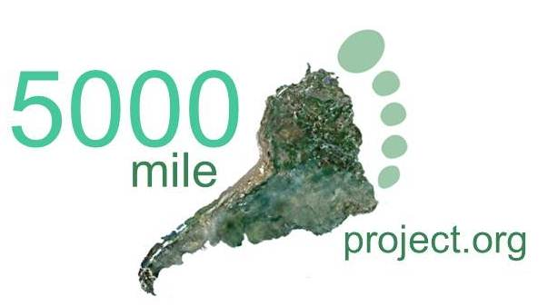
MEDIA RELEASE
For Immediate Release, Thursday, January 19 2012
British couple to run 5000 miles for the wilds
On 27 July 2012, as the Olympic gun resonates through the streets of London, Katharine and David Lowrie, will begin an epic journey to run, unsupported, 5000 miles across South America in a year.
If running between 15 to 25 miles a day, through steaming Amazonian rainforest, over snow-clad Andean passes and against biting Patagonian winds isn’t enough, they will also be undertaking an ambitious project to inspire and link people from around the world to South America’s wilds and raise money for conservation charities.
Katharine and David will be pulling their ‘office’ and kit behind them, to allow them maximum flexibility. They will run from northern Venezuela, Caribbean Sea, to Cabo Froward, Southern Ocean; the most southerly point of the South American Continent.
‘Designing the convertible trailers is critical to the expedition. We’re looking for a manufacturer to build the custom two-wheeled frame from ultra-light aluminium and cold moulded timber. We need it to take the burden of our gear off our shoulders and backs and onto our hips. Otherwise the shear load over such a long distance would dangerously overload our backs. It has to deal with the motion of our strides over dirt roads, tarmac and crossing the Andes Mountains twice. It’ll need to convert into a back-pack for the rough ascents and have breaks for the descents’.
The ‘5000 mile project’ is hosted at 5000mileproject.org, where people can find David and Katharine’s blog, the stats, science and online classroom.
‘It’s been our dream for years now so it’s very exciting to be making our way to the start line. The response from people so far has been amazing. We want to involve our online community in the adventure, hazards and highlights, the challenges and choices; keeping them up-to-date with the people and wildlife we meet along the way. And if people want to get really active, they can run with us for sections of the route, by committing to raise money towards our conservation charities.’
David and Katharine’s online classroom will create a fresh take on learning, allowing schools to journey vicariously with them through South America’s wilds. Each day, after the running stops, they will also be surveying birds and habitats from the roadside, for their ‘mega-transect’.
‘The natural world is central to our lives. We want to undertake our greatest physical challenge and to raise money and awareness to conserve the last threatened ecosystems before it’s too late. We feel that by shedding tears and sweat and smashing the odd record, we can connect and inspire people to it’.

The expedition’s home is at www.5000mileproject and www.facebook.com/5000mileproject. They are currently seeking sponsorship.
ENDS
For further information, to arrange an interview or for photos, please contact Katharine and David at www.5000mileproject.org/contact, www.facebook.com/5000mileproject or by email at dave@listalight.co.uk.
David and Katharine are currently living on their old wooden boat in Uruguay; planning and training for the expedition. At the end of June they will begin the slow bus journey north to the start line.
Four years ago Katharine and David set sail from the SW of the UK on a voyage to work in international conservation. They have since published the ‘Seabird Breeding Atlas of the Lesser Antilles’ in partnership with EPIC, a Caribbean conservation charity. The Atlas is available from the CreateSpace online store https://www.createspace.com/3565696 as well as Amazon.com.
Katharine formally worked for the RSPB, a national wildlife charity in the UK, as a conservation advisor. David worked as a management consultant for the world’s largest business consultancy. Together they decided to commit their lives to the natural world and seek adventure. They have sailed over 20,000 nm in their quest, surveying wildlife along the way, whilst seeking to have as little impact on the environment as possible. To find out more about their voyage so far visit www.listalight.co.uk .
Before they can concentrate on fundraising for their charities, they need sponsorship to cover the costs of the expedition. The expedition will be ‘lean and mean’ but they’re running for a year and want to have as great an impact as possible. They need funding for a range of expenses such as: communications which will allow them to keep people involved from the roadside; binoculars, digital bird guides, camping gear, running shoes, two running trailers, insurance etc. They’re feeding their wedding fund into the project, but this unfortunately falls well short of the overall budget.

